Analyzing the COVID-19 Provider Relief & Reimbursement Funds Distributions

Gabriel Penzo

Rutgers School of Health Professions

Visualization in Health Informatics

Professor Lorena Carlo

November 28, 2023

The healthcare system suffered many changes during the COVID-19 pandemic. From personnel shortages to increased expenses, the healthcare entities of the world were hit the hardest during this time. Many programs were made available for both providers and patients to lessen the economic hardships. Two of these were exclusively introduced to help providers who were in the first lines of the COVID-19 response. The COVID-19 Provider Relief Fund distributed $178 billion to many healthcare facilities, which was established under the Coronavirus Aid, Relief, and Economic Security Act (CARES). This fund “was meant to help providers prevent, prepare for, and respond to coronavirus and to reimburse… eligible health care providers for health care related expenses or lost revenues that are attributable to coronavirus” (Coughlin, 2022).

The federal legislation funded a Health Resources and Services Administration program that accepted claims for reimbursement in United States healthcare facilities. The COVID-19 Claims Reimbursement to Health Care Providers and Facilities for Testing, Treatment, and Vaccine Administration for the Uninsured Program provided 18 billion in reimbursements to healthcare sites that would cover COVID-19-related expenses of uninsured patients. “The HRSA program has paid approximately $11.4 billion for testing, $5.85 billion for treatment, and $1.6 billion for vaccines” (Waltz, 2022). This program required that providers would agree to a post-reimbursement audit review, given the large amounts of money being reimbursed. The program began accepting claims in April 2020 and stopped on March 22, 2022.

1. Introduction and background

During the COVID-19 pandemic, many programs were created to help both patients and providers. One of those programs, The COVID-19 Claims Reimbursement to Health Care Providers and Facilities for Testing, Treatment, and Vaccine Administration for the Uninsured Program, was made to reimburse facilities that were providing testing, vaccines, and treatments to uninsured patients. Another program, The HHS Provider Relief Fund, was created to provide funds to healthcare providers on the frontline of the COVID-19 response (Administration, 2023). Quality healthcare is very important, and facilities need funding to provide an exceptional experience that meets the patient's needs. While this was a great response during the pandemic, many aspects of the healthcare system still fall short in terms of providing care and being accessible to everyone. Many questions arise about how these funds were distributed. **Which states received more money and which ones received less? How were the amounts distributed?** My presentations aim to answer these questions. This will help the readers be informed about the economic measures taken during the COVID-19 healthcare crisis and will benefit others by helping them understand how a Relief Fund works and how money is distributed to healthcare facilities.

My inspiration comes from how quality healthcare is hardly accessible to many individuals and how this funding made it easier for the uninsured and all patients to receive life-saving treatments during the pandemic. I chose this topic to understand how funding is distributed in each state and facility and to explore the many variables that affect this outcome. I would like to understand the difference between the amounts made available for the variables of testing, treatments, and vaccines.

1. Datasets

The datasets that I intend to use for this project are the HHS Provider Relief Fund dataset collected by the HHS ASPA (Administration, 2023), the Claims Reimbursement to Health Care Providers and Facilities for Testing, Treatment, and Vaccine Administration of the Uninsured dataset collected by the HHS ASPA (ASPA, 2022), and the Our World in Data Coronavirus Vaccinations dataset ( (Coronavirus (COVID-19) Vaccinations, 2023). The Provider Relief Fund and the Claims Reimbursement datasets were found on the CDC website. The COVID-19 dataset was found on the Our World in Data website. The two programs were funded by the United States Department of Health and Human Services under the Coronavirus Aid, Relief, and Economic Security Act (CARES). The datasets by HHS have information about each state that received funds. The third dataset has general information about COVID-19. The Provider Relief dataset has 4 variables (Provider Name, State, City, and Payment) and 420,000 observations that go into detail about the provider facilities, amounts distributed, and in which state they are located. The claims reimbursement dataset has 6 variables (Provider Name, State, City, Claims Paid for Testing, Claims Paid for Treatment, and Claims Paid for Vaccine) and 50,200 observations. This dataset also contains a georeferenced column that points to the location of the different cities in which the providers are located. The Our World in Data dataset has 67 variables (I will only use Date, New Vaccinations, and People Fully Vaccinated variables), and 358,721 observations with information about COVID-19 statistics such as deaths, tests, vaccinations, and other data. With these datasets, I can make graphs at the facility and state levels, which will help me answer the questions that arise. A big limitation present in the HHS datasets is the lack of dates and times. If it had dates on which the providers received the amount, it would greatly improve the data. This would allow the reader to also make comparisons by looking at a timeline being visualized in a line graph. Another limitation is that due to the large number of providers' names and cities in the datasets, the visualizations will focus on each state rather than on each provider.

1. Data Story

**Claims Paid for Testing by State:** The data for this visualization comes from the Claims Reimbursement dataset. In the first visualization, I created a map that shows the amounts given to each state through the Provider Reimbursement Program that would cover testing expenses. By looking at the map, we can see that California, Illinois, Texas, and New York were the states that got reimbursed the most. California was reimbursed $1,923,847,552, Illinois: $1,382,317,985, Texas: $1,252,954,418, and New York, $858,009,228. The states with the most amounts are shown in a darker gray than the rest.

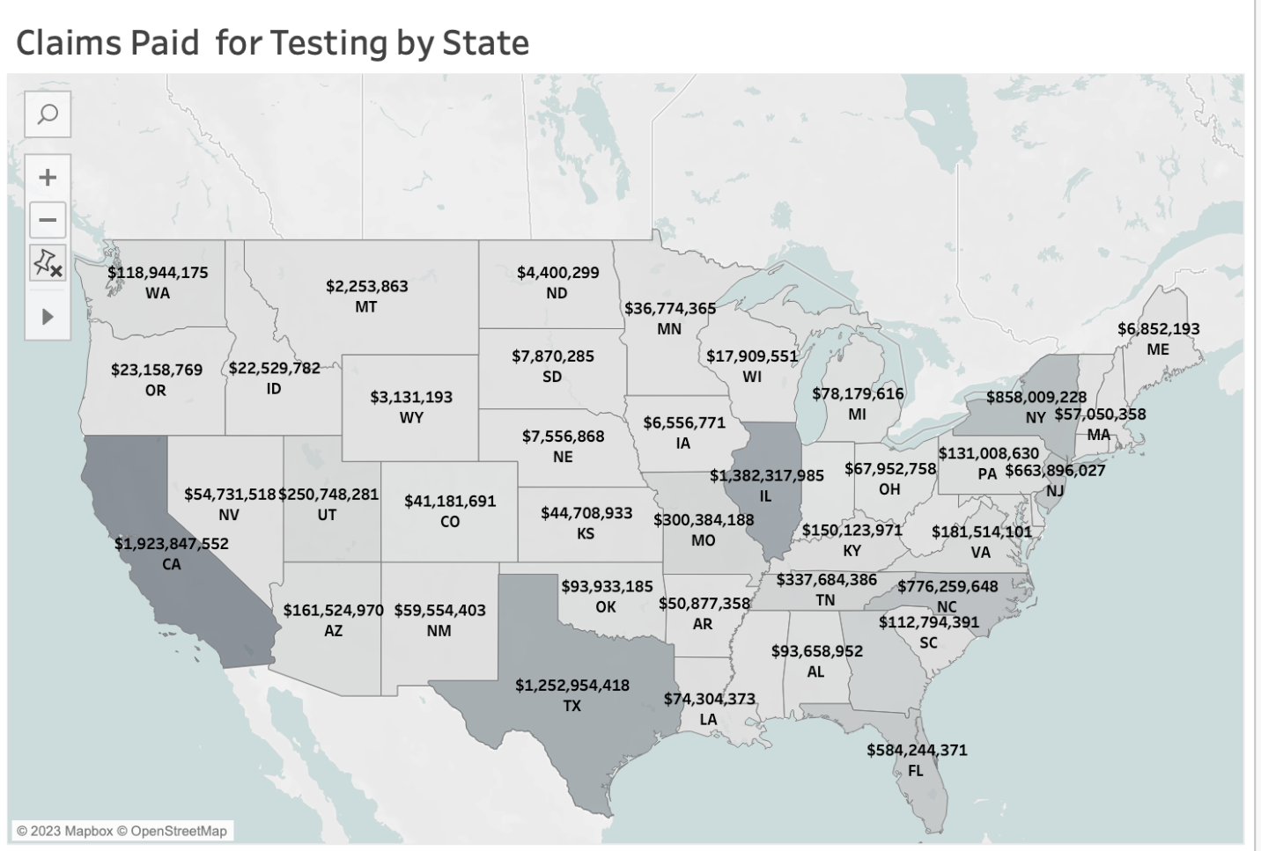

**Claims Paid for Treatment by State:** The data for this visualization comes from the Claims Reimbursement dataset. In this visualization, a bar chart shows the amounts reimbursed in each state. This bar chart is in descending order to show the states with the higher amounts reimbursed. This time, Texas is in first place with $1,803,073,501, Florida follows with $572,228,465, Georgia is in third place with $407,497,544, and surprisingly, California is next with $367,461,171. We can see that there is a big difference in amounts given for testing and treatment in California. This can be due to a higher number of uninsured patients who didn’t test positive in this state and therefore didn’t require treatment. Meanwhile, Texas shows more money given for treatments than for testing.

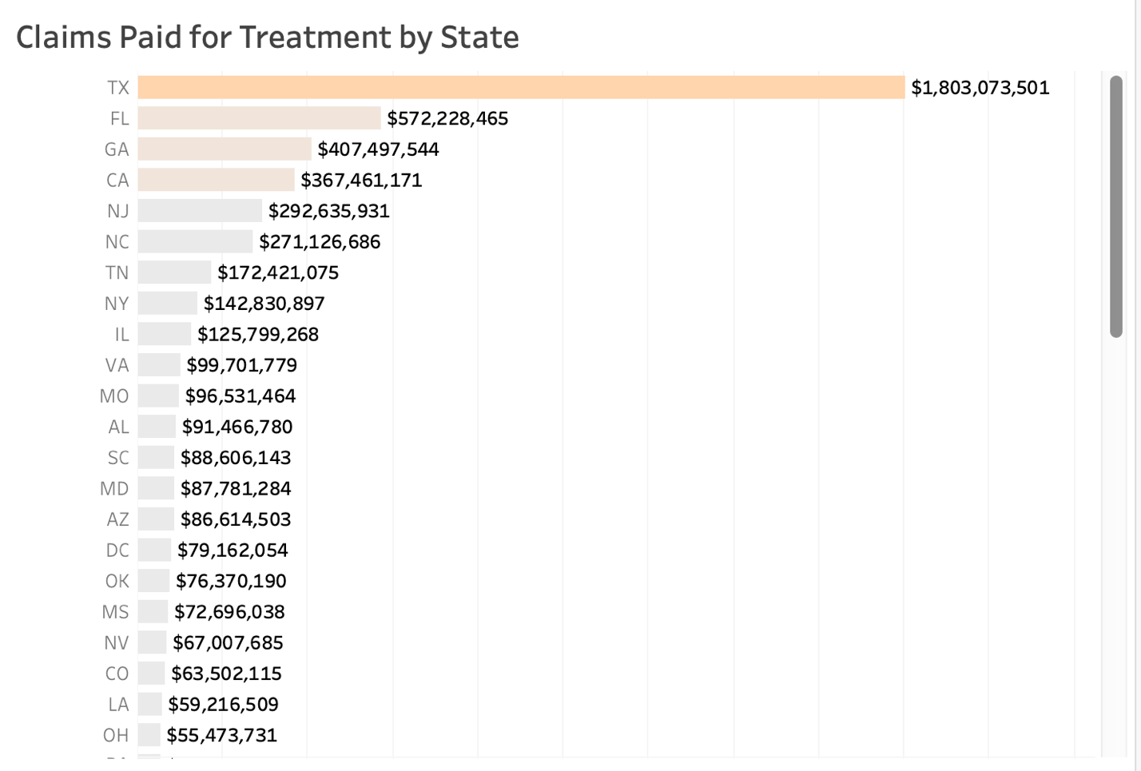

**Claims Paid for Vaccines by State:** The data for this visualization comes from the Claims Reimbursement dataset. In the third chart, a bar chart shows the amounts reimbursed to states to cover vaccine expenses for uninsured patients. The first thing we can see on this chart is that the amounts given to each state are way lower than the amounts given for testing and treatments, with the highest amount being only $320,729,636 in Illinois. California follows with just $184,720,086, and Arizona, with $184,760,086. New Jersey is next with $132,849,079.

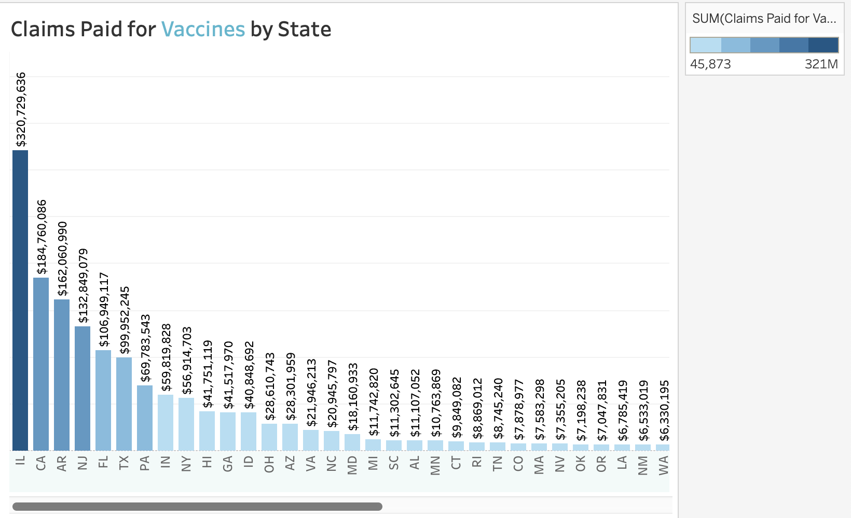

**Total Vaccinations in the United States:** The data for this visualization comes from the COVID-19 dataset from Our World in Data. There are two line charts that show the number of new vaccinations and total vaccinations in the US. The “New Vaccinations” line chart shows the number of new vaccinations each year from 2020 to 2023. The “Total Vaccinations” line chart also shows the data from 2020 to 2023. This will help the reader to understand if there is any correlation between the amounts reimbursed by claims and the total amount for vaccines in the country.

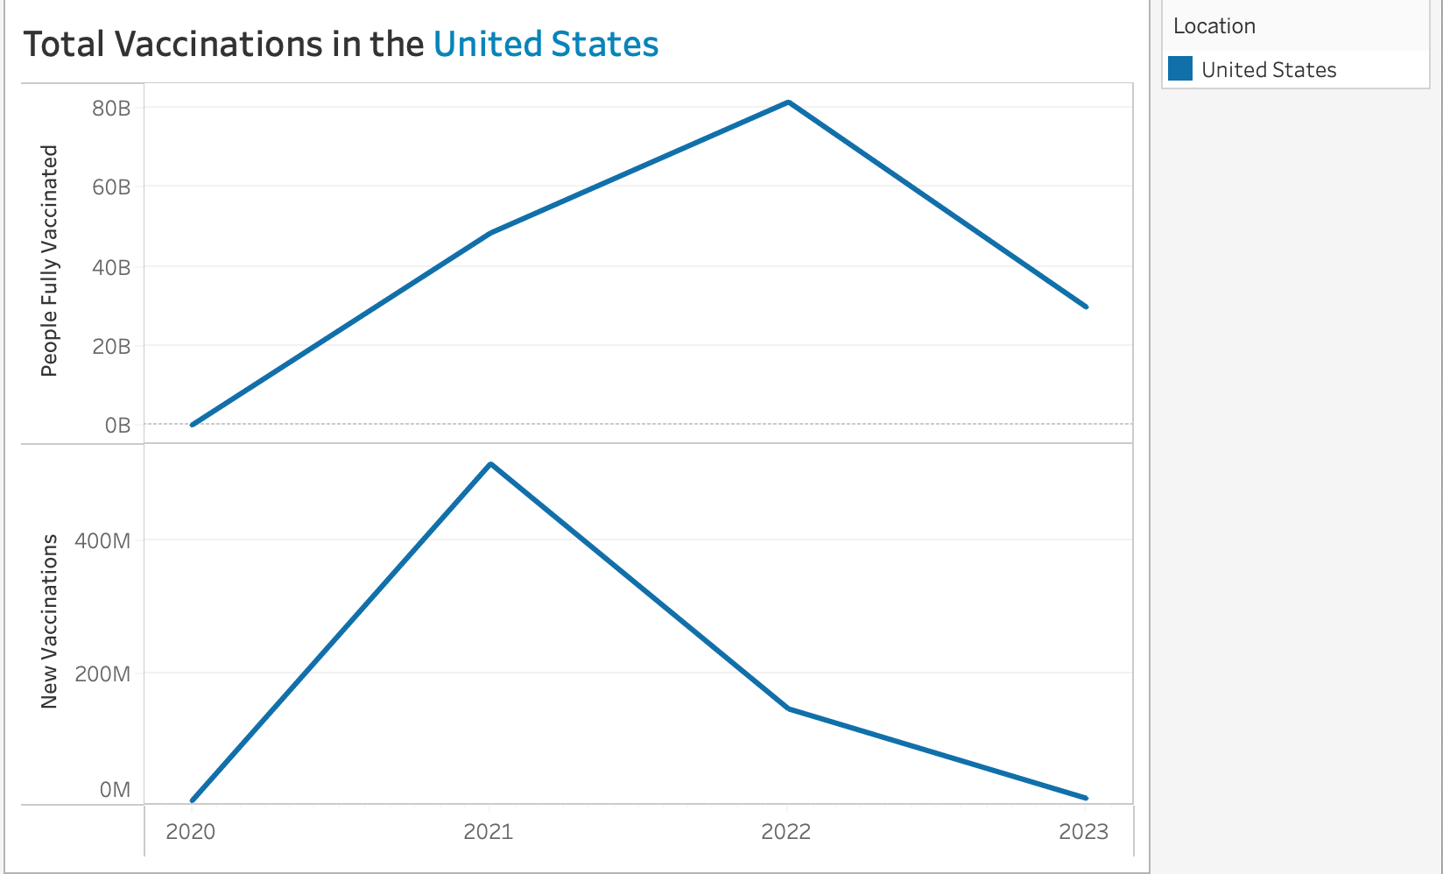

**All Claims Paid by State:** The data for this visualization comes from the Claims Reimbursement dataset. This scatter chart shows all the claims reimbursed for the three categories: testing, treatment, and vaccines. We can see how each amount compares in each state. It is interesting to note that:

* Arizona, Idaho, and Hawaii are the only states that show more reimbursements given for vaccines than the other categories.
* Texas is the only state that shows a higher amount reimbursed for treatments than for testing and vaccines.
* Most states show a higher amount reimbursed for testing than for treatments and vaccines.
* The amounts reimbursed for the state of Texas are very dissimilar. While Texas shows more than two billion being reimbursed for testing and treatments, it was only reimbursed $99,952,245 for vaccines, which is barely less than 10% if compared to the other categories.

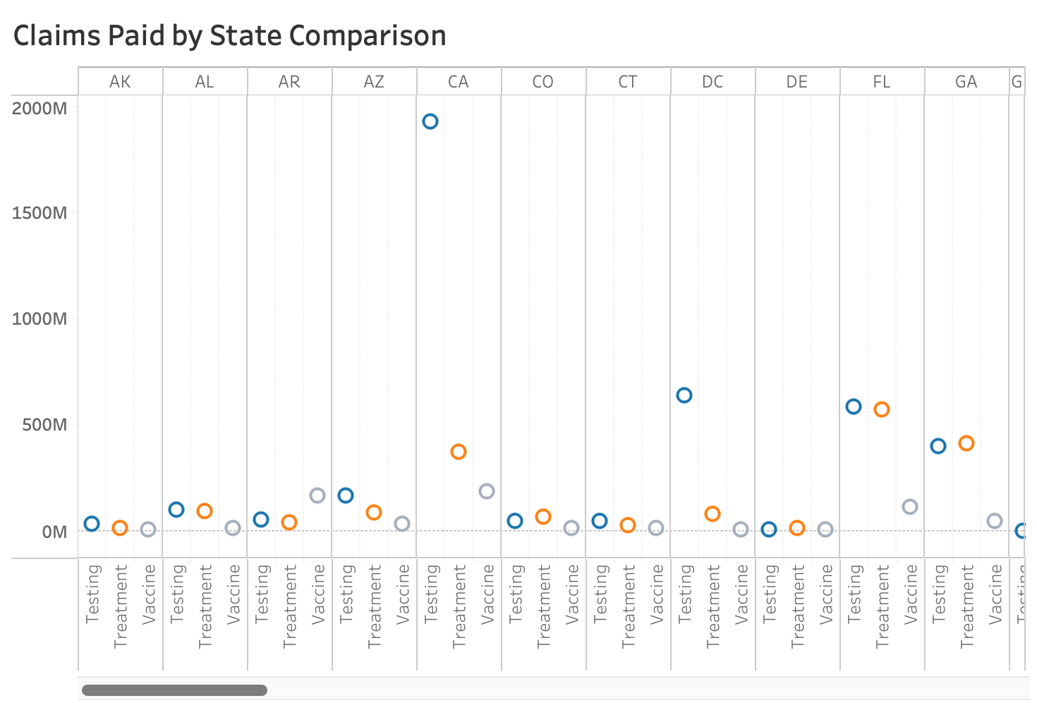

**Provider Relief Fund Payments:** The data for this visualization comes from the Provider Relief Fund dataset. This bar chart shows the amounts given for each state from the Provider Relief Fund to facilities in the front lines of the COVID-19 response to cover expenses and losses. The states of New York ($15,034,420,660), California ($12,850,231,894), and Texas ($9,670,751,989) show the most amount given.

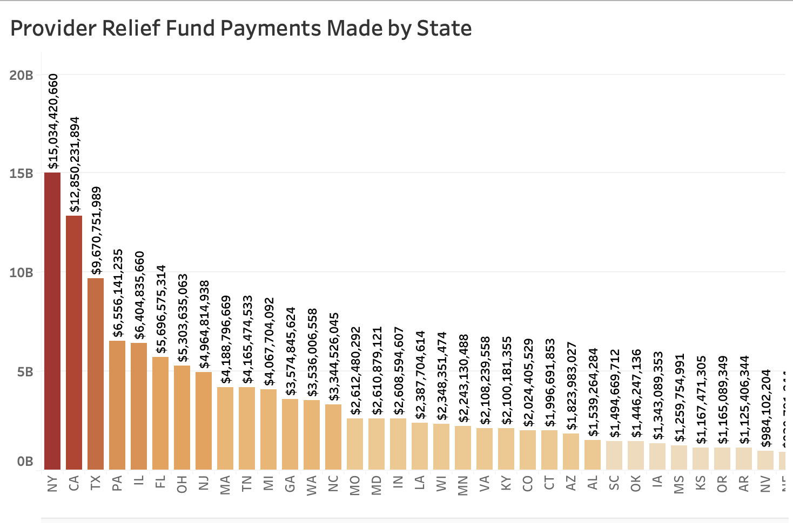

**Payments in NY, CA, TX:** The data for this visualization comes from the Provider Relief Fund dataset. This visualization is a table that goes into detail about the states with the highest amount. This table shows the different cities and amounts given in these three states. In California, the cities of Los Angeles ($1,235,545,231), Sacramento ($1,017,172,164), and San Francisco ($651,483,039) were the cities that were given the higher amounts. The state of New York has New York City ($4,553,787,527), Westbury ($1,332,929,505), and Brooklyn ($1,326,444,070). In Texas, Dallas ($2,936,193,720), Houston ($1,541,584,486), and Fort Worth ($367,212,350). It is interesting to note that much of the money that was distributed to Texas went to Dallas and Houston facilities.

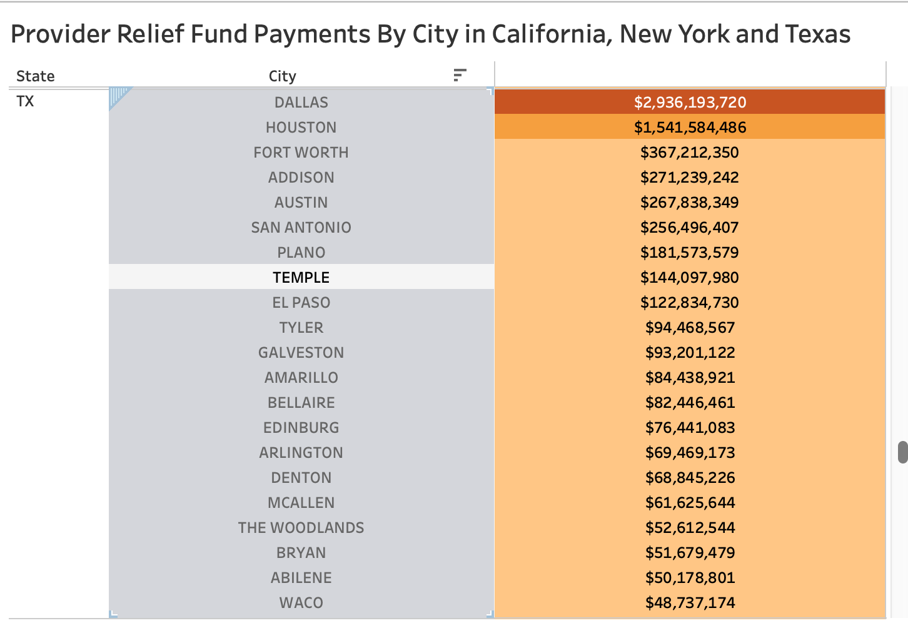

**Payments by City in California, New York, and Texas:** The data for the map visualizations comes from the Provider Relief Fund dataset. This symbol map shows California cities that were given higher amounts in bigger circles and the other cities with less amounts in smaller circles. It is interesting to note that most of the cities that received higher amounts were close to Los Angeles ($1,235,545,231), San Francisco ($1,017,172,164), and Sacramento ($651,483,039). These cities received higher amounts compared to other cities in California.

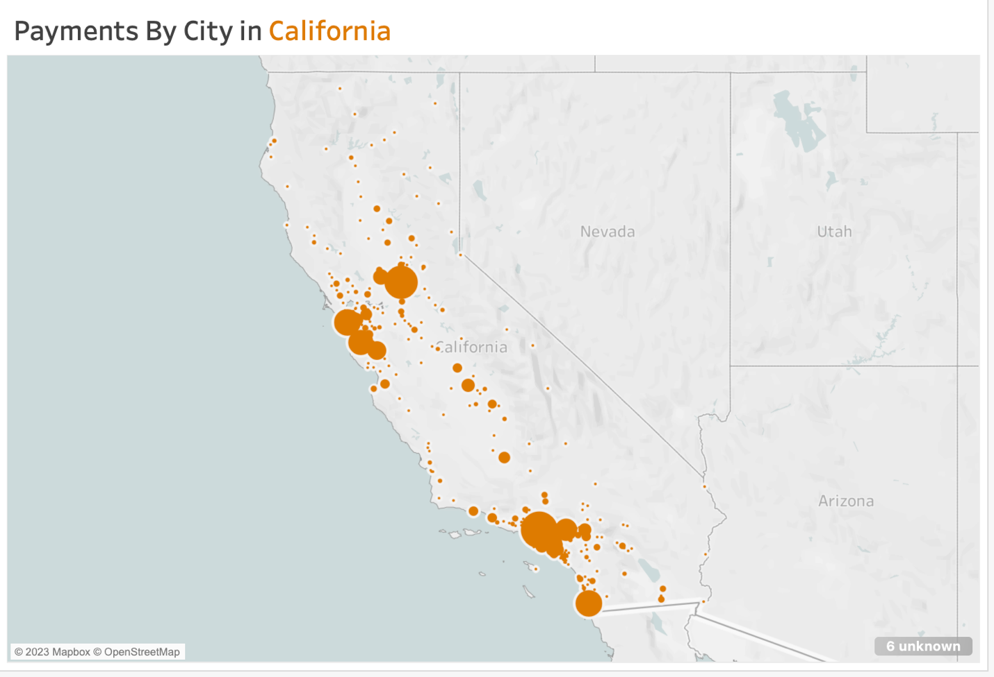

For New York, we see that this also happens. The cities of New York City ($4,553,787,527), Bronx ($1,063,832,941), Brooklyn ($1,326,444,070), and Westbury ($1,332,929,505) received higher amounts and many adjacent cities received funds in a lesser amount. Other cities like Buffalo ($355,954,339), and Rochester ($478,817,390) also show a higher amount compared to other nearby cities.

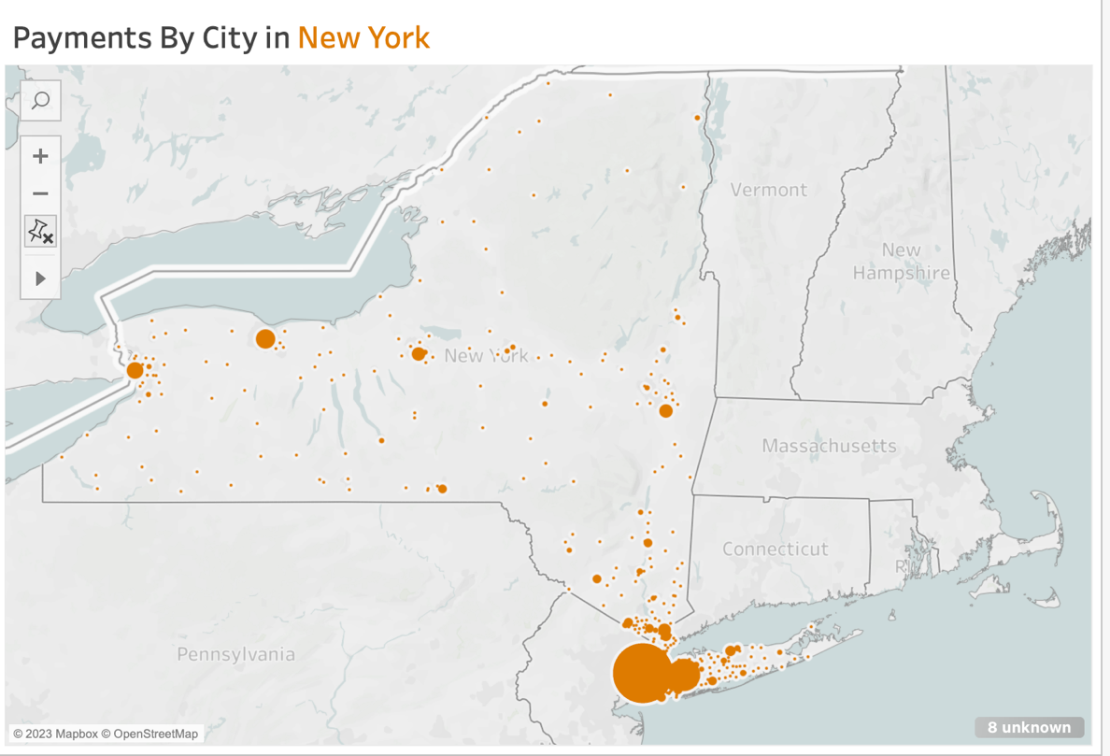

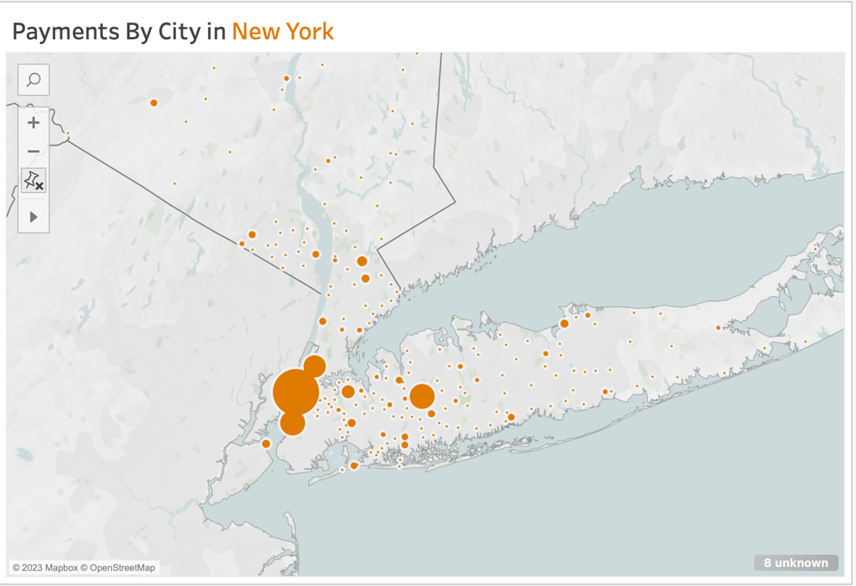

In Texas, we see a different trend in the cities. Many cities across all of Texas received a similar amount of money, while Dallas and Houston showed a higher amount.

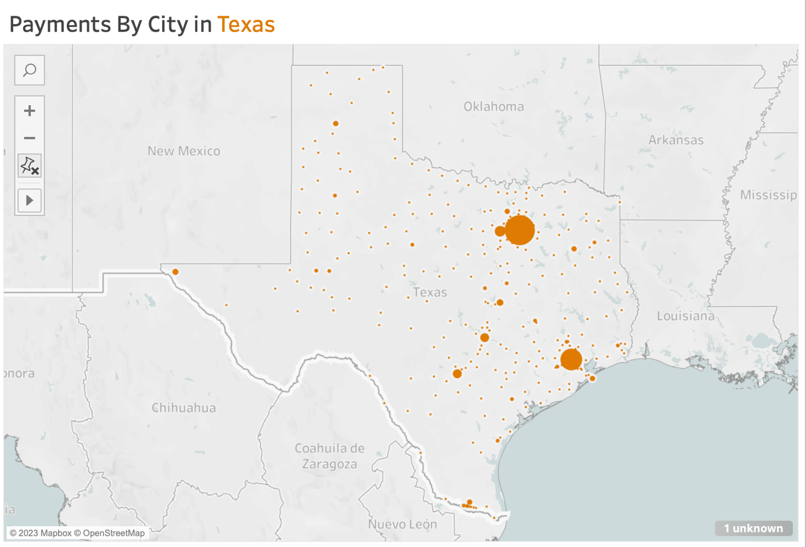

**Provider Relief Fund Payments in CA, NY, and TX Summary:**

The dashboard shows the three states and includes an interactive filter that allows the reader to search for cities in each state (must be typed in all caps). The dashboard helps to address my goals since it allows the reader to have a better understanding and comparison tool when interacting with the maps and searching for the cities that may be of interest.

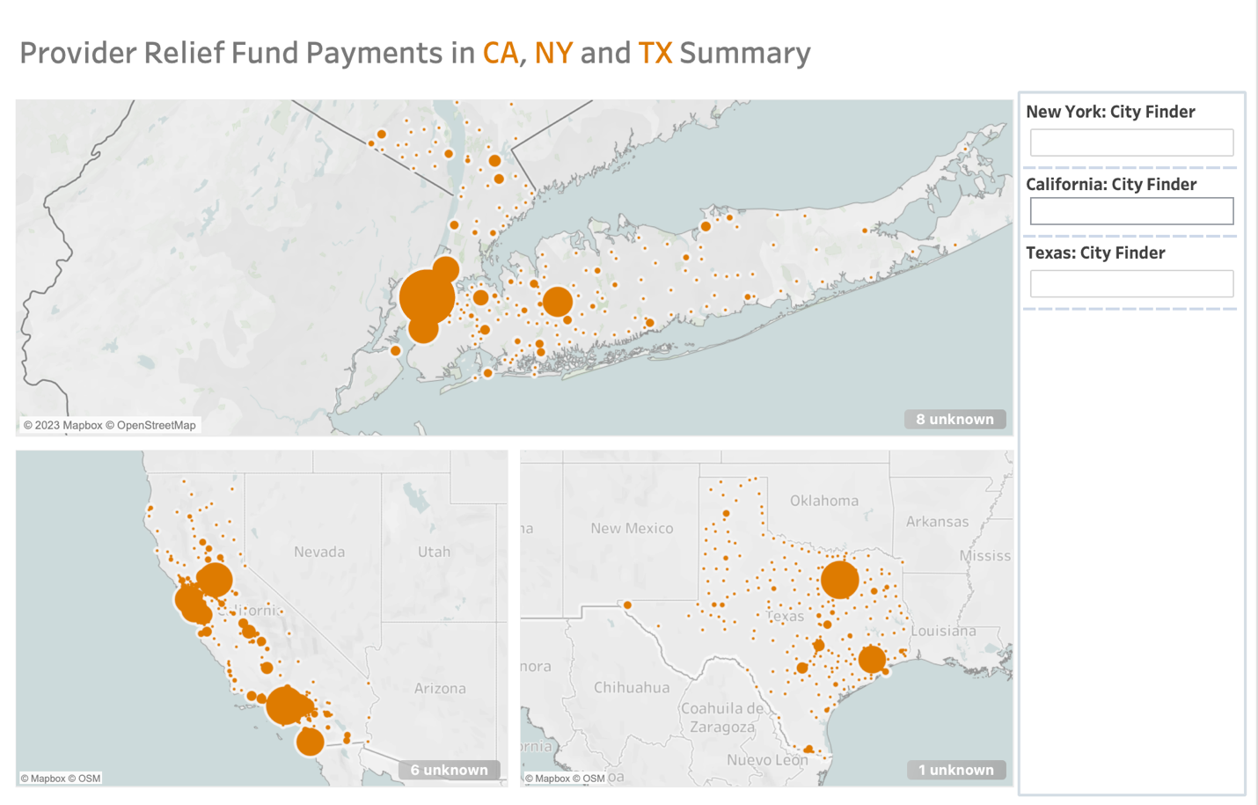

**Data Story on Tableau:**

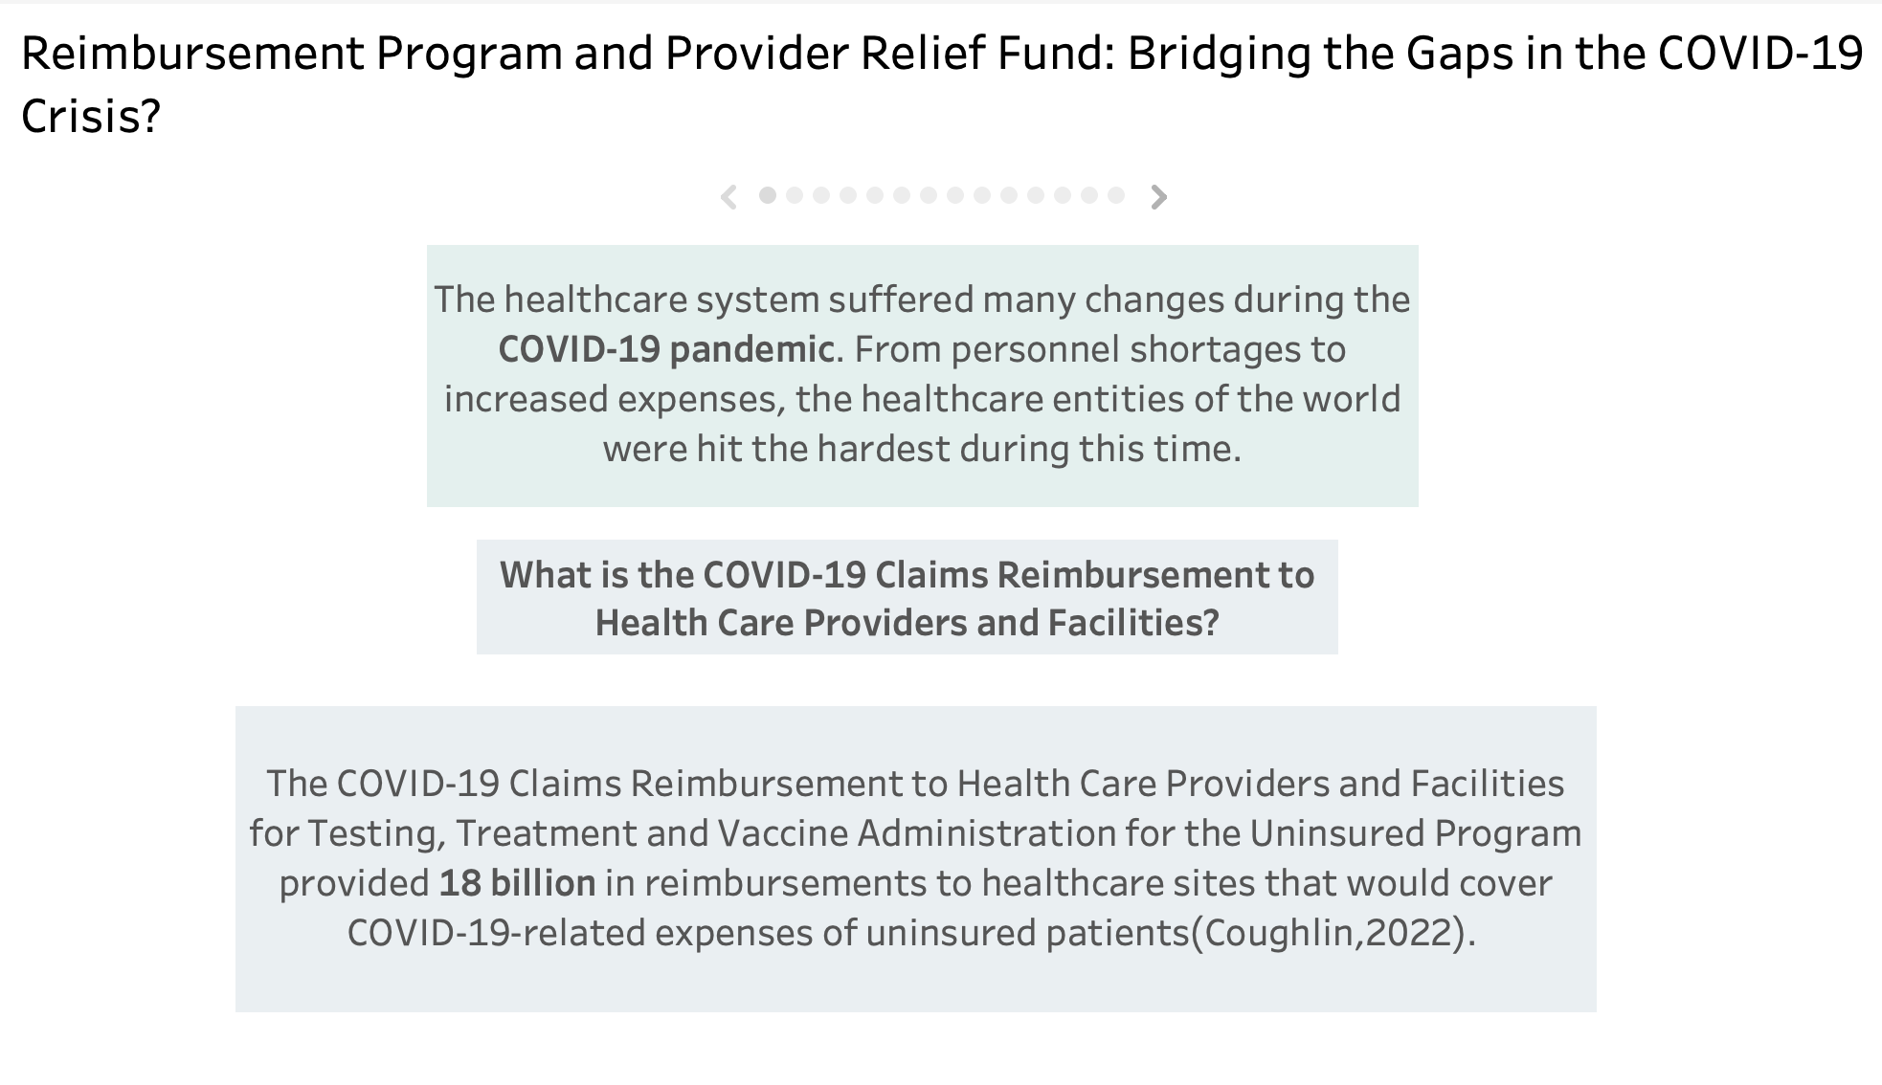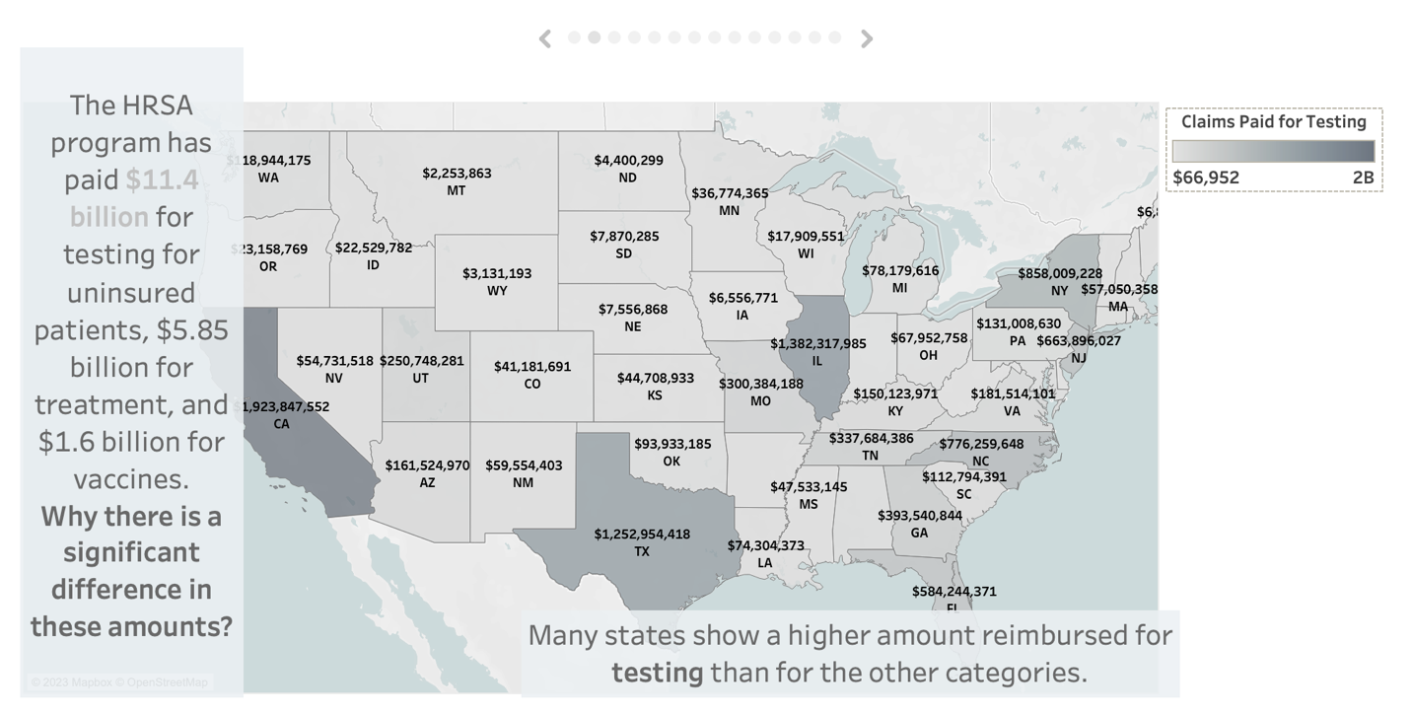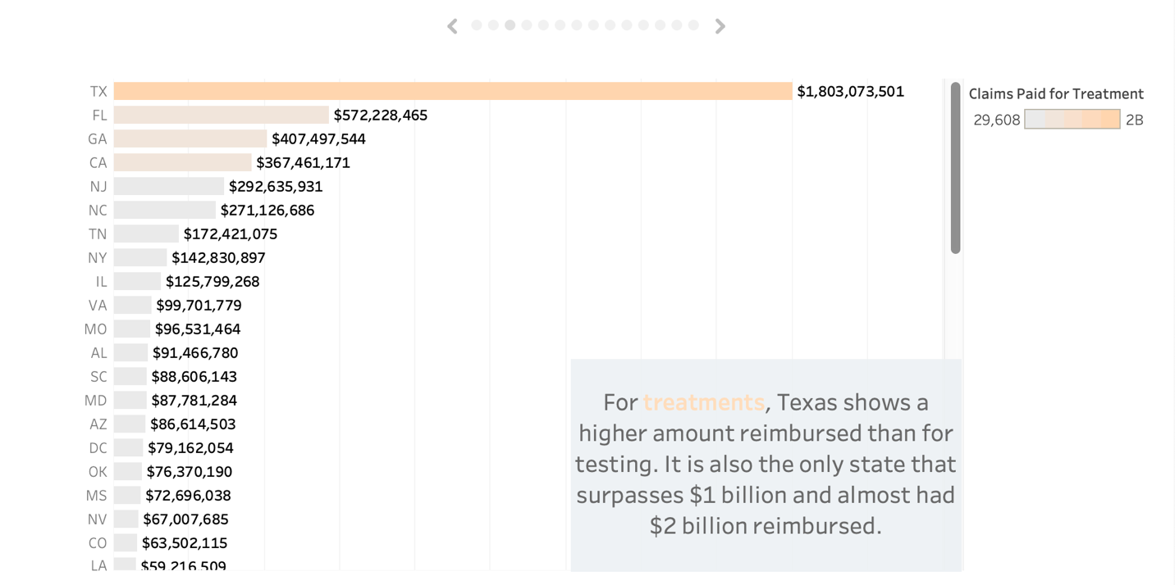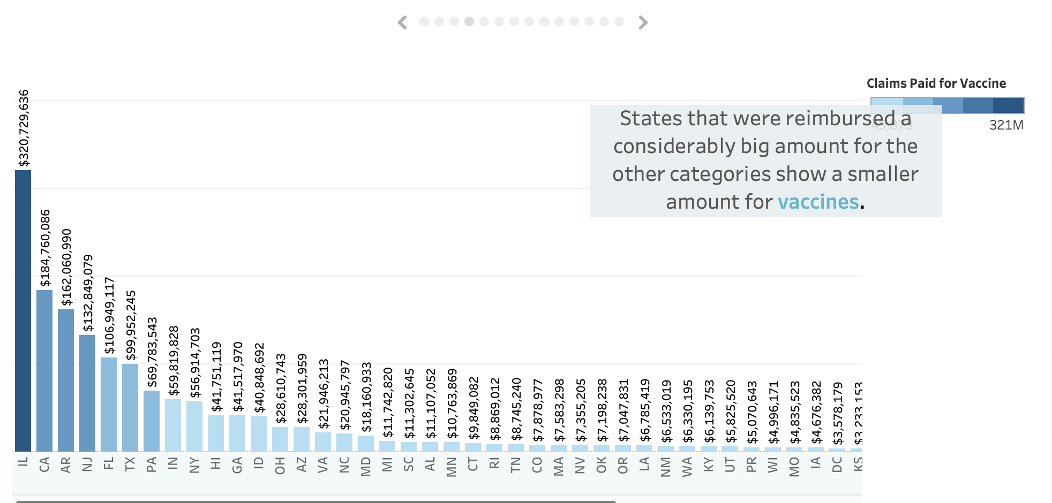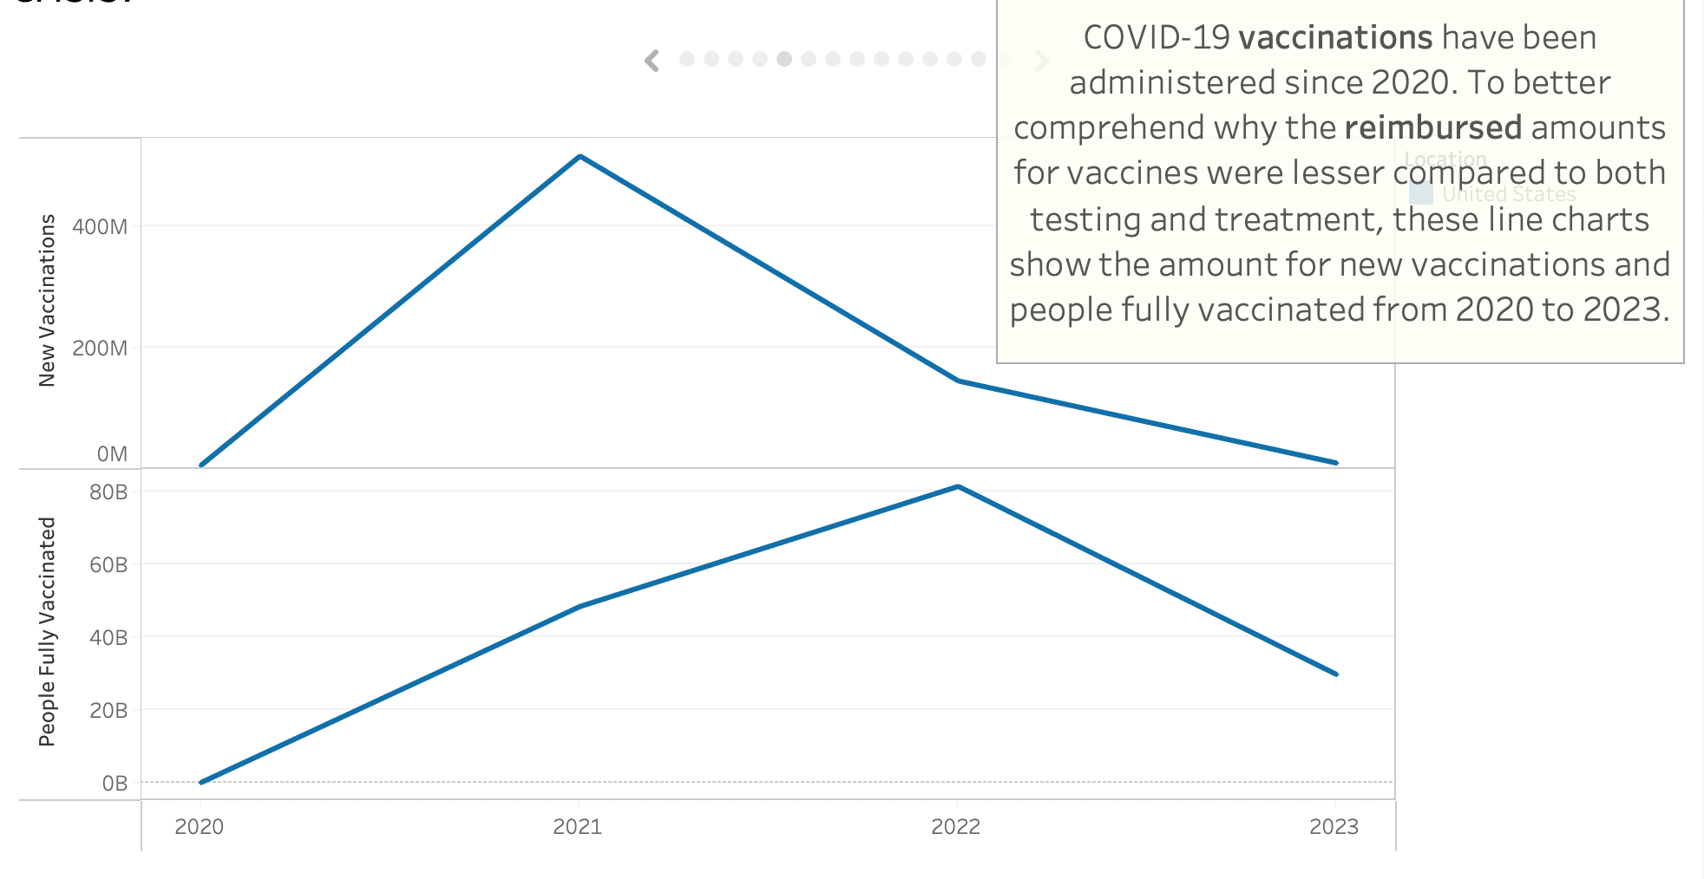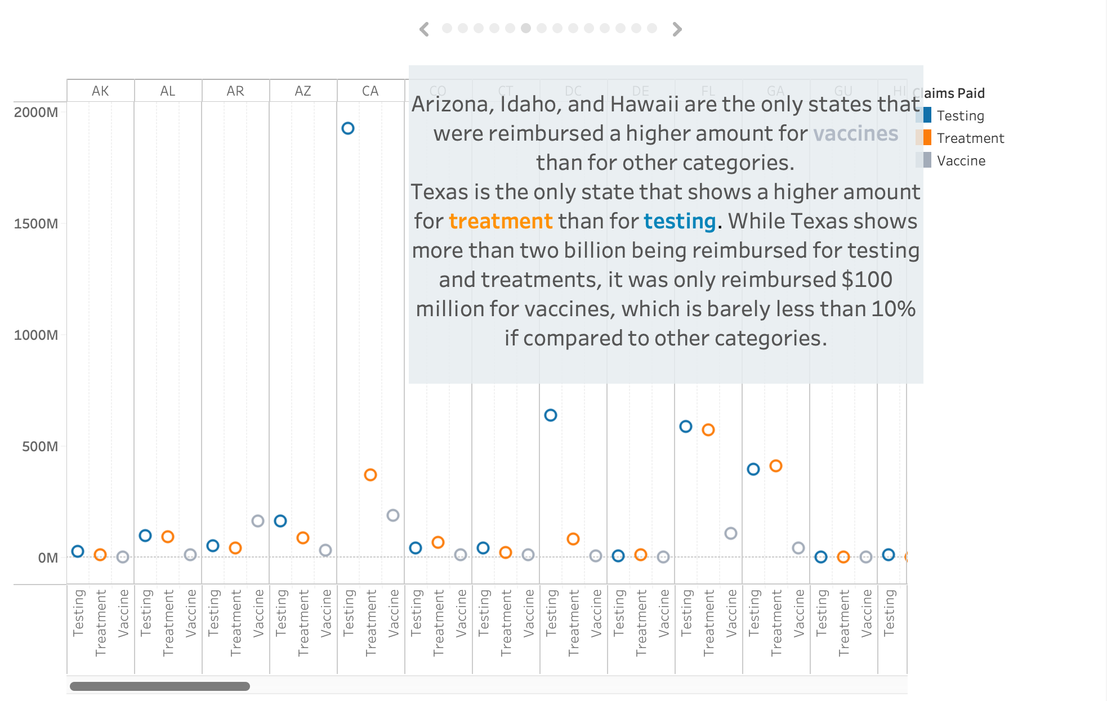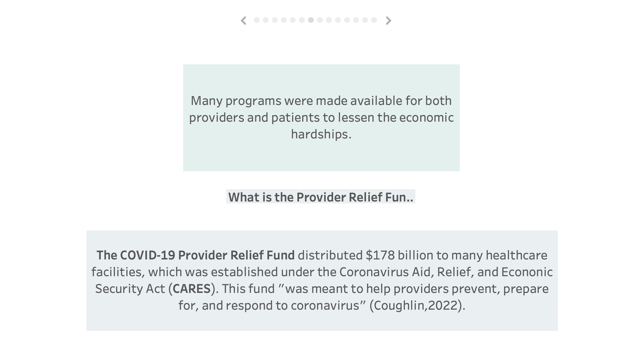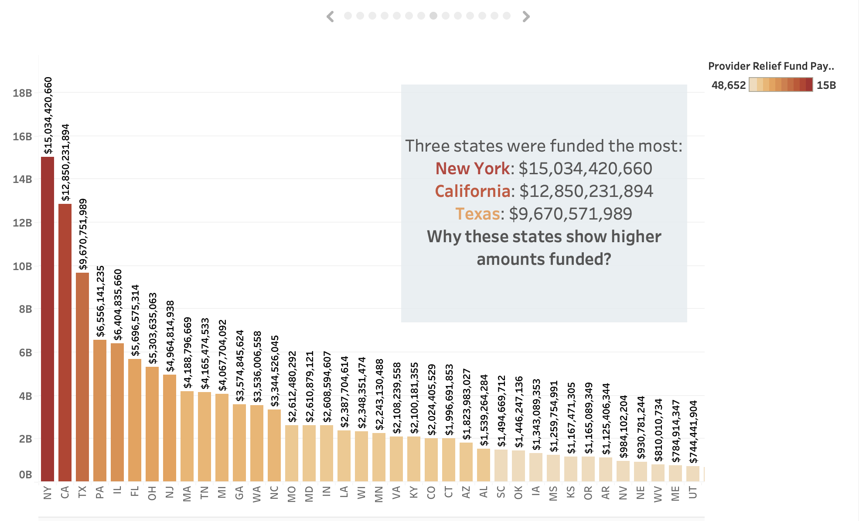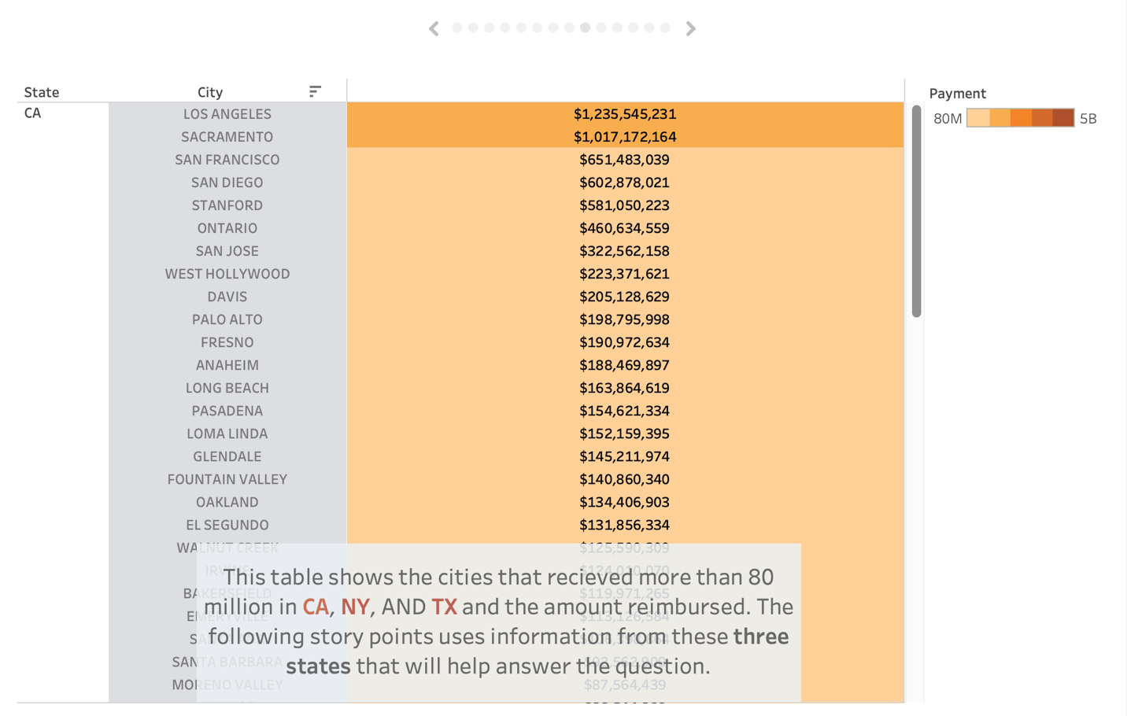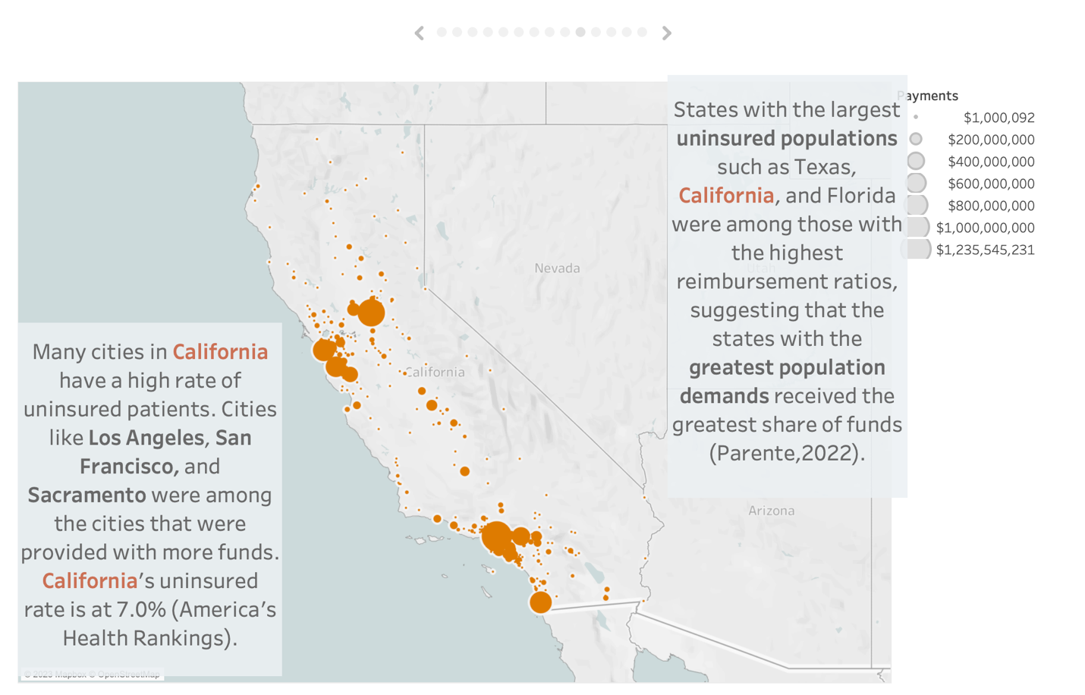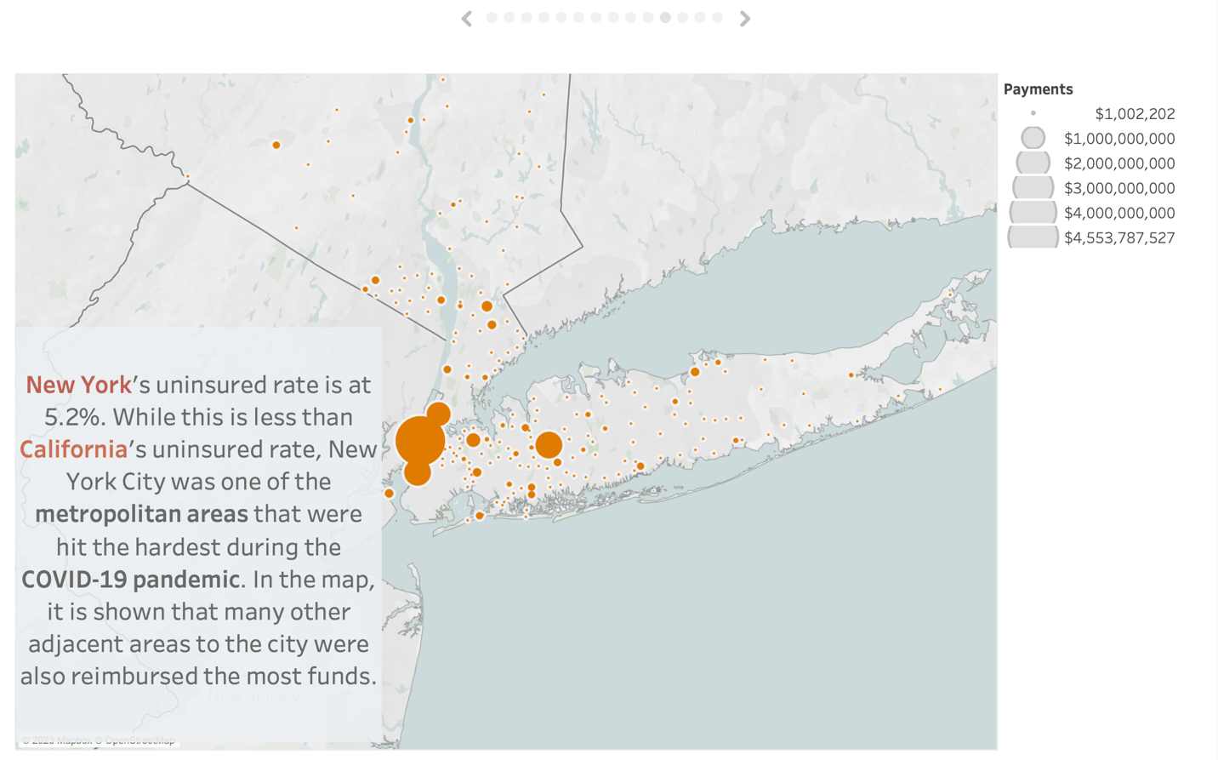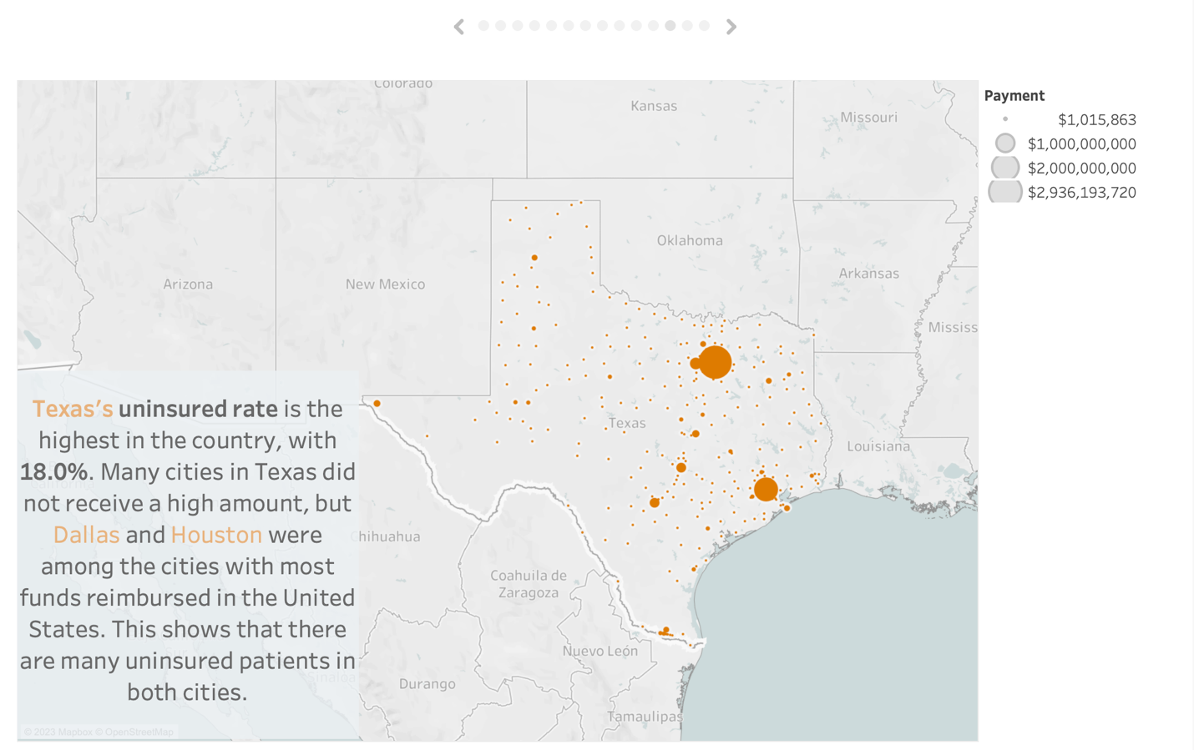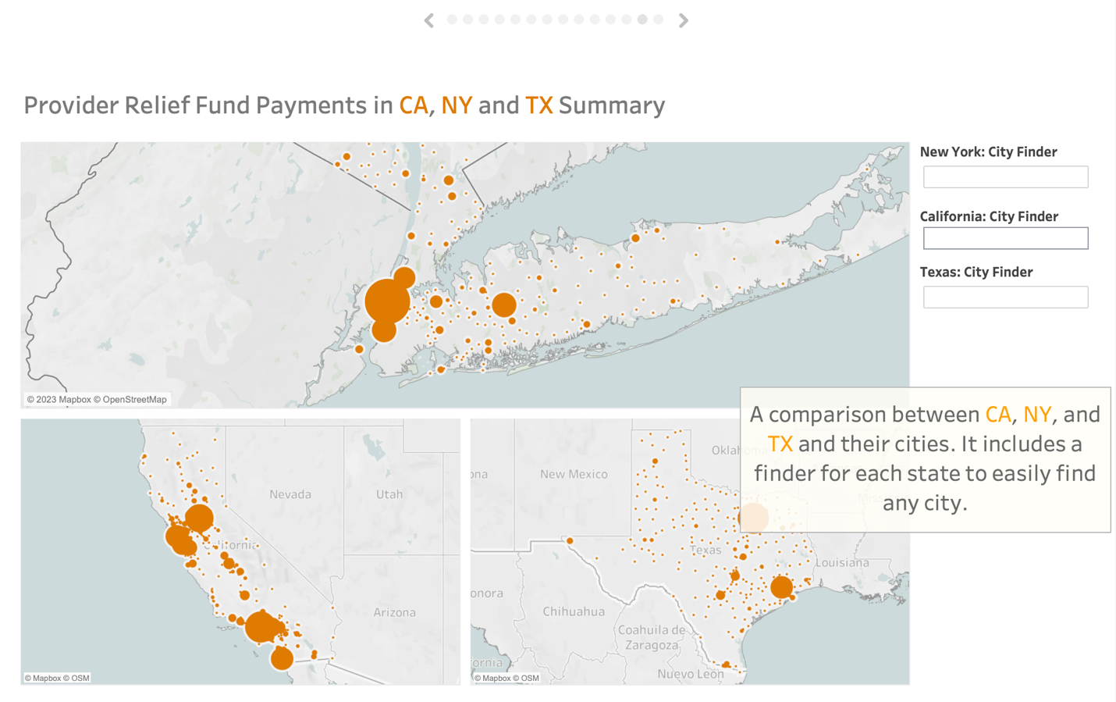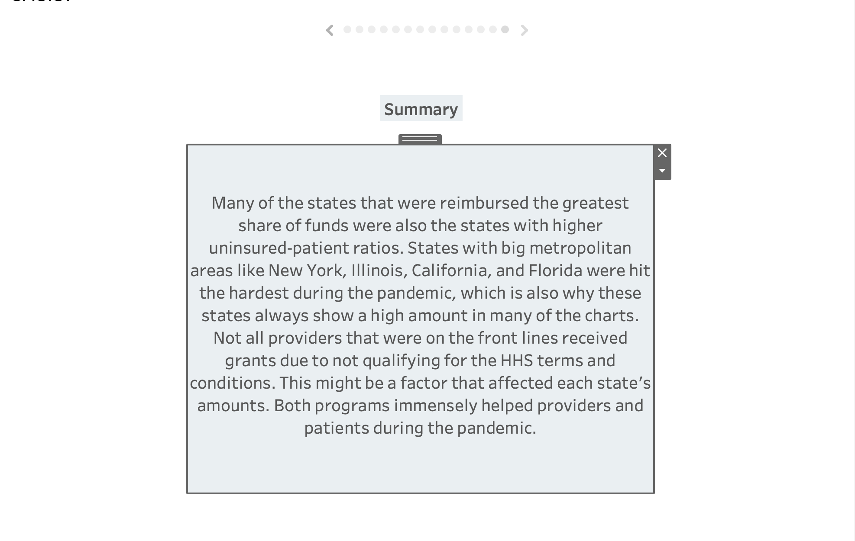

1. Conclusions

Both the Claims Reimbursement Program and the Provider Relief Fund aided many facilities in the country, and while most of the amounts went to states like Texas, California, New York, and New Jersey, we can see that every state got at least an amount of money from both funds. It makes sense that these states got the most money since the pandemic hit these states the hardest. “States with the largest uninsured populations such as Texas, California, and Florida were among those with the highest reimbursement ratios, suggesting that the state with the greatest population demands received the greatest share of funds” (Parente, 2022). California’s uninsured rate is 7.0%, meanwhile, New York shows a smaller ratio of 5.2%. Texas has the highest ratio in the country with 18.0% (America's Health Rankings, 2022). While the funds immensely helped facilities since the creation of the programs, they faced criticism and controversy since “these funds were not being released in a timely manner” and “that the funds’ eligibility criteria systematically disadvantaged providers that were already underresourced, especially safety net hospitals on the front lines of the pandemic response” (Coughlin, 2022). Not all providers that were on the front lines received grants due to not qualifying for the HHS terms and conditions. The data in these visualizations aims to explain how the ones that did qualify were granted these amounts and it was distributed in each state.

References

Administration, H. R. (2023, September 27). *HHS Provider Relief Fund*. Retrieved from CDC: https://data.cdc.gov/Administrative/HHS-Provider-Relief-Fund/kh8y-3es6

*America's Health Rankings*. (2022, December). Retrieved from Uninsured in the United States: https://www.americashealthrankings.org/explore/measures/healthinsurance

ASPA, H. (2022, March 3). *Claims Reimbursement to Health Care Providers and Facilities for Testing, Treatment, and Vaccine Administration of the Uninsured*. Retrieved from Centers for Disease Control and Prevention: https://data.cdc.gov/Administrative/Claims-Reimbursement-to-Health-Care-Providers-and-/rksx-33p3

*Coronavirus (COVID-19) Vaccinations*. (2023, November 27). Retrieved from Our World in Data: https://ourworldindata.org/covid-vaccinations

Coughlin, T. A. (2022, August). *The COVID-19 Provider Relief Fund*. Retrieved from Urban Institute: https://www.urban.org/sites/default/files/2022-08/The%20Covid-19%20Provider%20Relief%20Fund.pdf

Parente, S. T. (2022, January 28). *Assessment of the Provider Relief Fund Distribution for Treatment of Uninsured Patients With COVID-19*. Retrieved from National Library of Medicine: https://www.ncbi.nlm.nih.gov/pmc/articles/PMC8903101/

*Uninsured in United States*. (n.d.). Retrieved from America's Health Rankings: https://www.americashealthrankings.org/explore/measures/healthinsurance

Waltz, J. A. (2022, April 07). *Health Providers Must Avoid COVID Reimbursement Missteps*. Retrieved from Foley & Lardner LLP: https://www.foley.com/en/insights/publications/2022/04/health-providers-void-covid-reimbursement-missteps